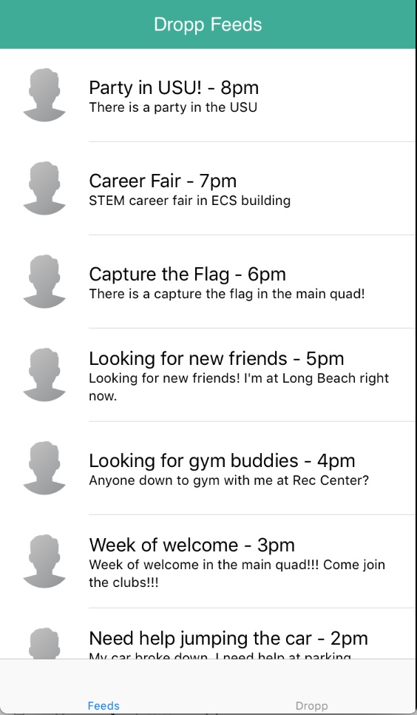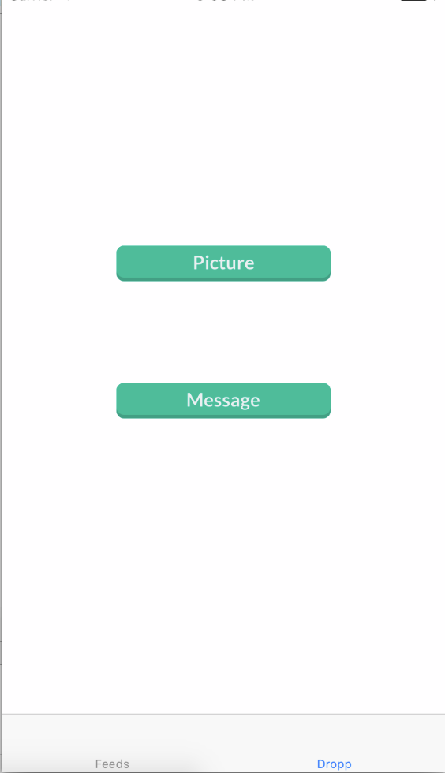

**Dropp Select**

Here, the user can either Dropp a picture or message.

1. Tapping “Picture” transfers the app to the “Dropp Photos Permission Check” page if it doesn’t have permissions to access photos. Otherwise, the app transfers to the “OS Album Select” page.
2. Tapping “Message” transfers the app to the “Dropp Picture Send” page without any picture selected.
3. Tapping “Feeds” transfers the app to the “Front Page/Feed” page.

**Front Page/Feed**

The default page the user sees when the app finishes loading.

1. The feed displays all local messages along with their time of posting. Messages are ordered from newest to oldest going down. The user can scroll down by touch input to read older messages.
2. Tapping “Feeds” scrolls the Dropp Feed all the way to the top.
3. Tapping “Dropp” transfers the app to the “Dropp Select” page.

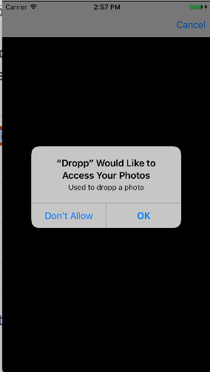

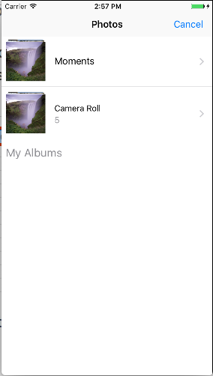

**OS Album Select**

Here, the user can select which album they’d like to choose their photos from.

1. Tapping on an album transfers the app to the “OS Picture Select” page.
2. Tapping “Cancel” brings the app back to the “Dropp Select” page.

**Dropp Photos Permission Check**

Here, the user can choose to give Dropp permission to access photos.

1. Tapping “OK” transfers the app to the “OS Album Select” page.
2. Tapping “Don’t Allow” transfers the app to the “Dropp Select” page.

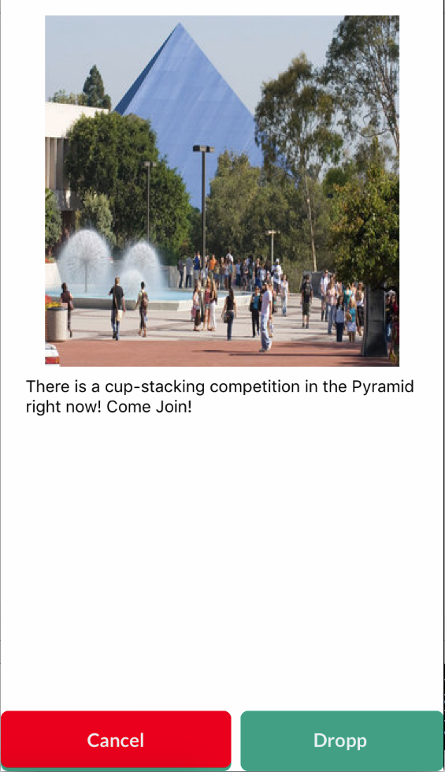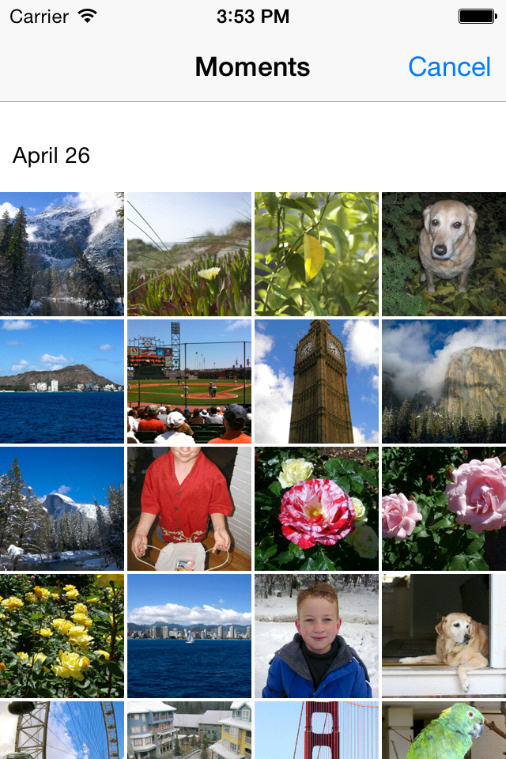

**Dropp Picture Send**

This is the picture message page.

1. Tapping on the white space prompts up the keyboard and allows the user to type a message as seen on the “Dropp Message Prompt”
2. Tapping “Dropp” will upload this message to the server.
3. Tapping “Cancel” brings the app back to the “Dropp Select” page.

**OS Picture Select**

Here, the user can select an image or go back to the “Dropp Select” page.

1. Tapping an image selects that image and brings the app to the “Dropp Picture Send” page.
2. Tapping “Cancel” brings the app back to the “OS Album Select” page.

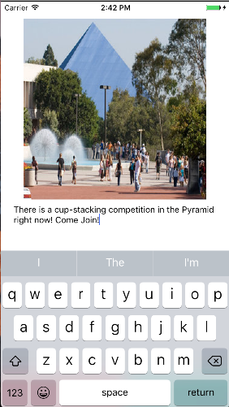

**Dropp Message Prompt**

Here, the user can select an image or go back to the “Dropp Select” page.

1. Tapping an image selects that image and brings the app to the “Dropp Picture Send” page.
2. Tapping “Cancel” brings the app back to the “Dropp Select” page.